**Level 3 Mini Signs 2019**

36 A. 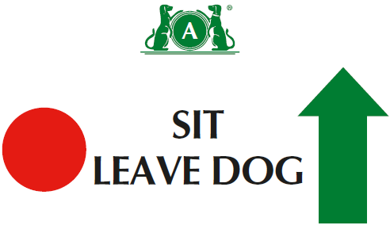

36 B. 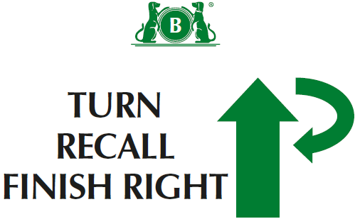

37 A. 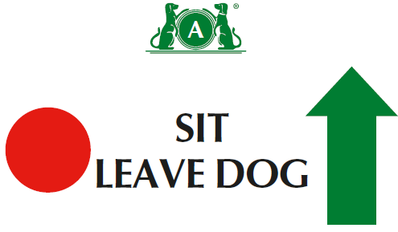

37 B. 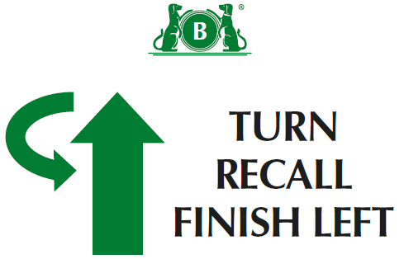

38. 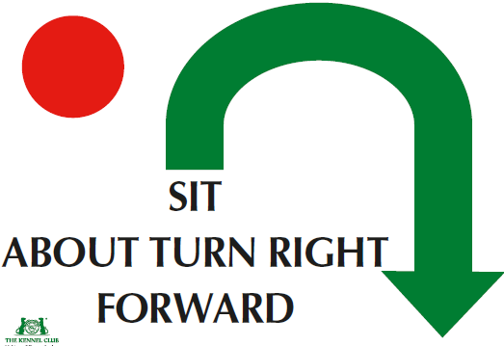

39. 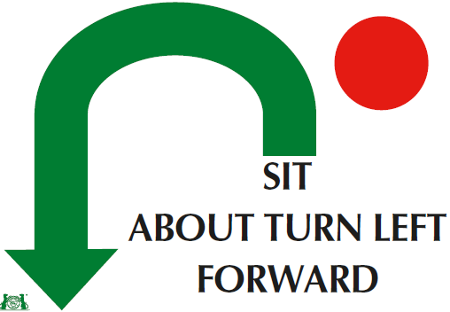

40. 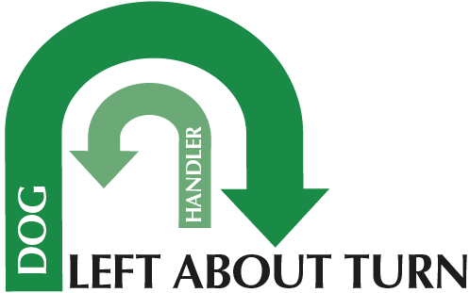

41. 

42. 

43. 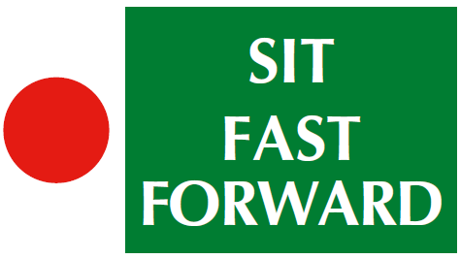

**Level 3**

(1) There should be a minimum of twelve and a maximum of fifteen exercises, with no more than eight static positions.

(2) There should be a ratio of one-third Level 3 exercises to two-thirds Level 1 and 2 exercises.

(3) A maximum of two exercises may be linked at this level.

(4) There should be a maximum of one Distraction Exercise, including the Bonus Exercise. (5)Can join 2 cone exercises using junction( ie across centre or at end at right angles)- advise use 1 different coloured cone if joining spiral to serpentine or fig 8.

(5) Bonus can come from Bonus exercises 1-8

(5) Bonus can come from bonus exercises 1 to 8

44 A. 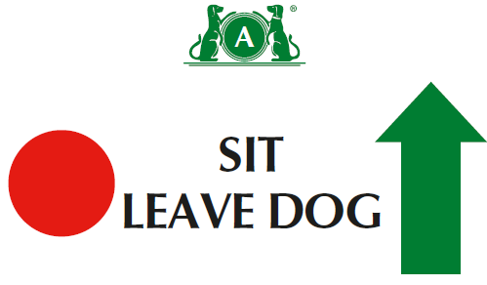

44 B. 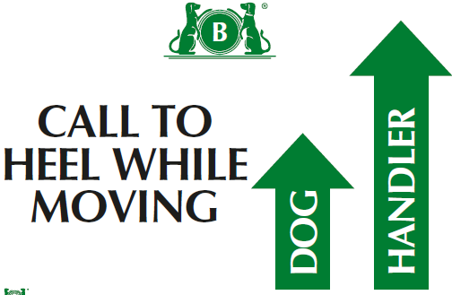

45. 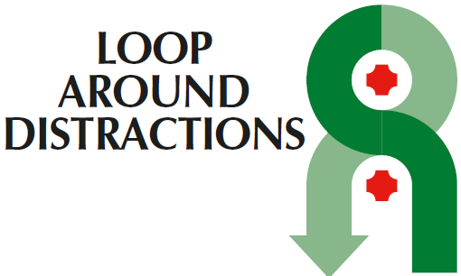

Bonus Ex 6

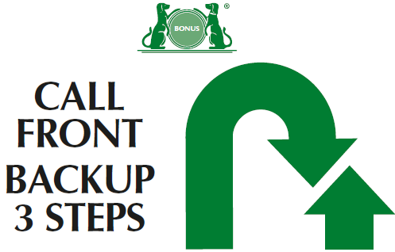

Bonus Ex 7 A

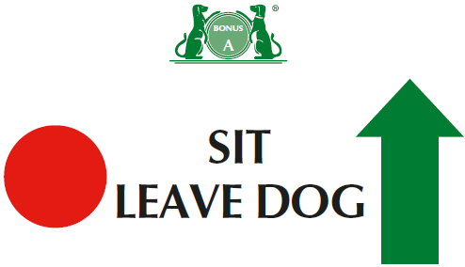

Bonus Ex 7 B

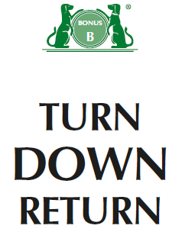

Bonus Ex 8 A

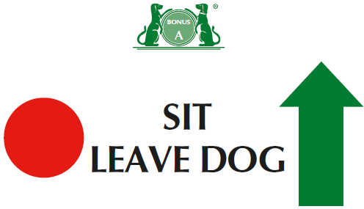

Bonus Ex 8 B

