**Level 4 Mini signs 2019**

46 A. 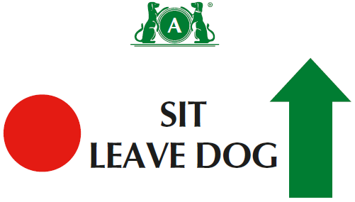

46 B. 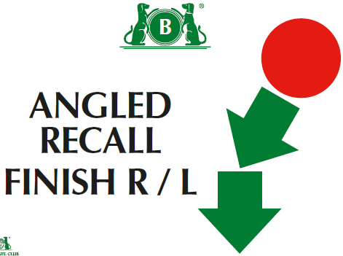

47. 

48. 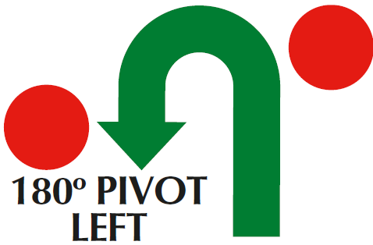

49. 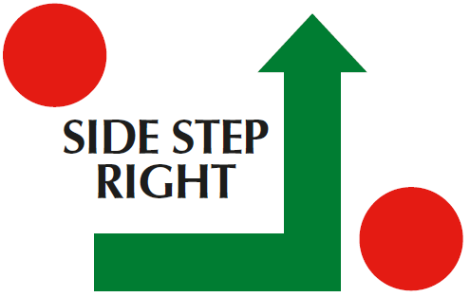

50. 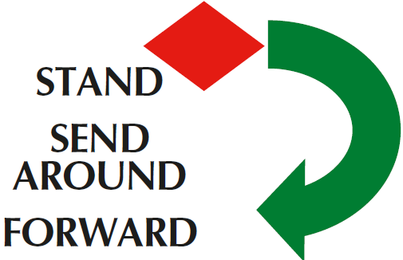

51. 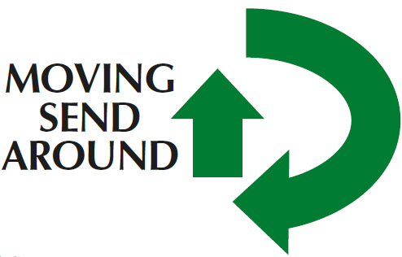

52. 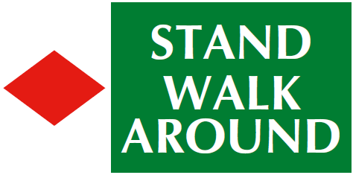

53. 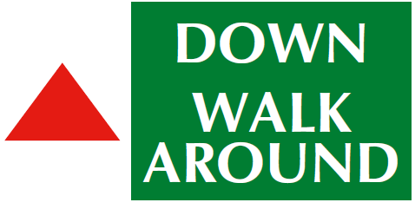

**Level 4**

(1) There should be a minimum of fifteen and a maximum of seventeen exercises, with no more than twelve static positions.

(2) There should be a minimum of one and a maximum of four exercises from Level 3, and a minimum of one and a maximum of four exercises from Level 4.

(3)More than 2 exercises can be linked and more than 1 distraction exercise is allowed

(4)Can join 2 cone exercises using junction( ie across centre or at end at right angles)- advise use 1 different coloured cone if joining spiral to serpentine or fig 8

(5) Bonus can come from Bonus exercises 1-10

Bonus can come from bonus exercises 1- 10

54 A. 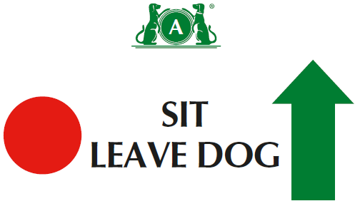

54 B. 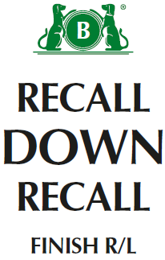

55. 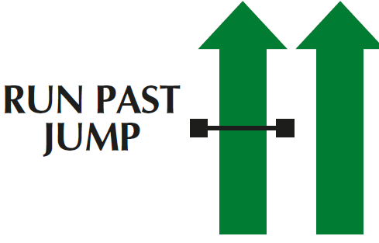

56 A. 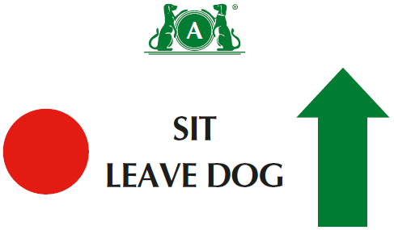

56 B. 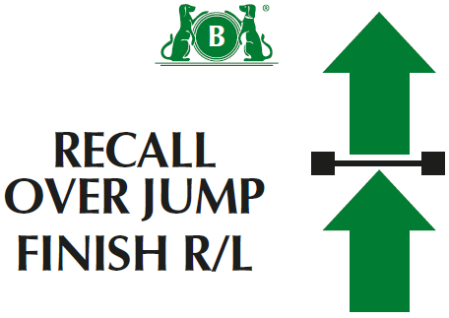

Bonus Ex 9

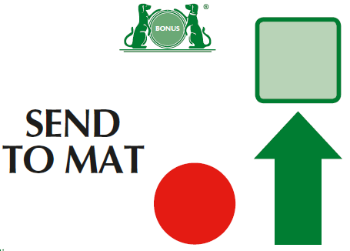

Bonus Ex 10 A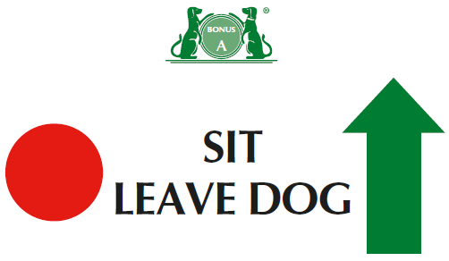

Bonus Ex 10 B 