**Level 5 Mini Signs 2019**

57 A. 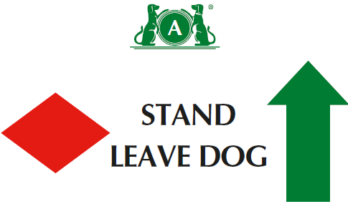

57 B. 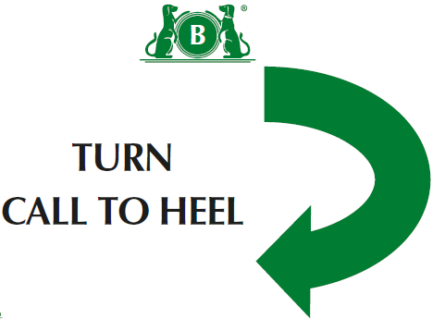

58. 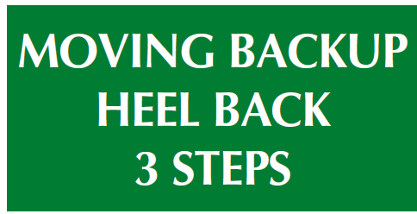

59. 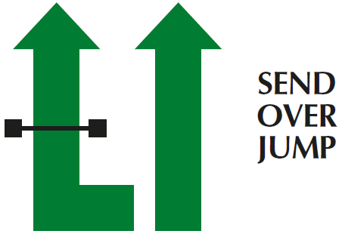

**Level 5**

(1) There should be a minimum of fifteen and a maximum of seventeen exercises, with no more than twelve static positions.

(2) There should be a minimum of one and a maximum of four exercises from Level 4, and a minimum of one and a maximum of four exercises from Level 5. )

(3) No more than 2 jump exercises in a course

(4) Can join 2 cone exercises using junction( ie across centre or at end at right angles)- advise use 1 different coloured cone if joining spiral to serpentine or fig 8

(5) Bonus can come from bonus exercises 1-12

60. 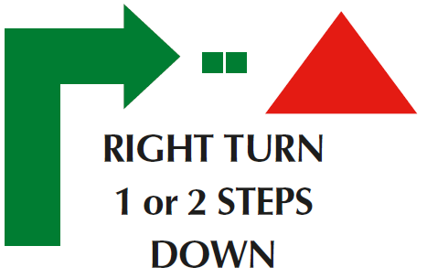

61. 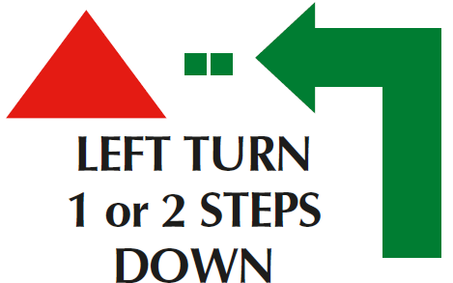

62. 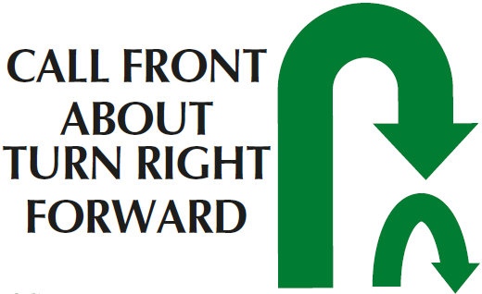

Bonus Ex 11

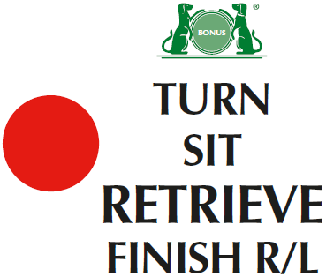

Bonus Ex 12 A

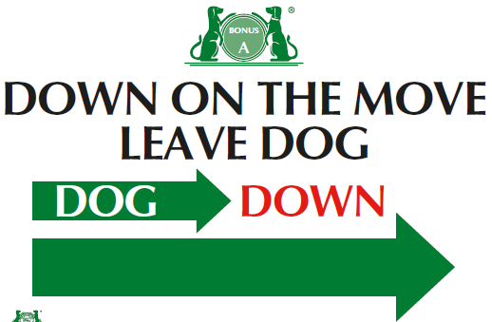

Bonus Ex 12 B

