Level 2 Mini signs 2019
23. 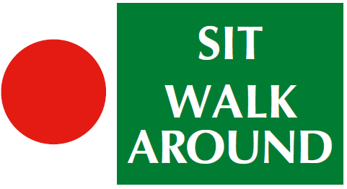
24. 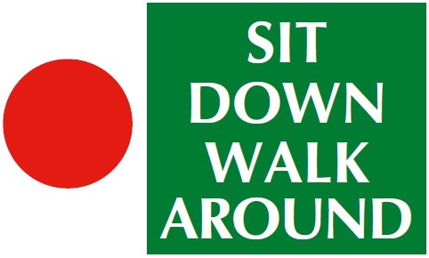
25. 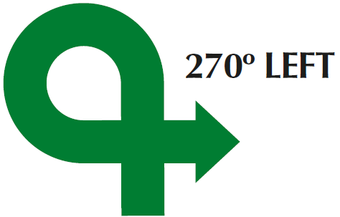
26. 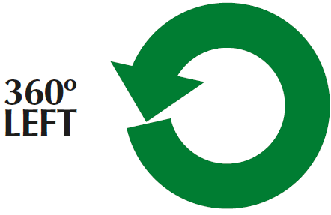
27. 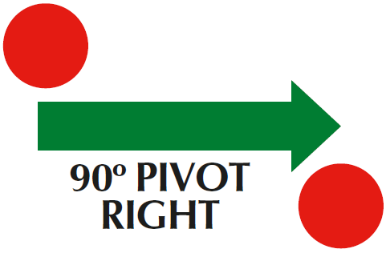
28. 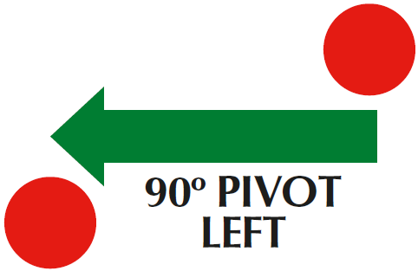
29. 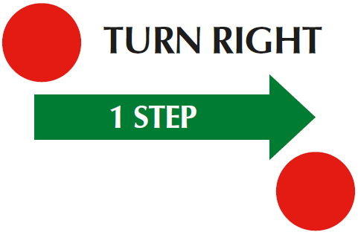
30. 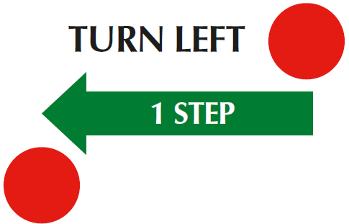
31. 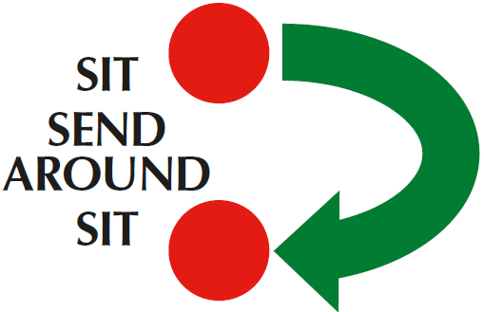
Level 2
(1) The same markers may be used in the execution of two exercises, for example cones used for Spiral Left, Spiral Right, Figure 8 or Serpentine. Junctions may not be used at this level.
(2) There should be a minimum of twelve and a maximum of fifteen exercises, with no more than eight static positions.
(3) There should be a ratio of one-third Level 2 exercises to two-thirds Level 1 exercises. ) (4) Can join 2 cone exercises but only in straight line, advise use 1 different coloured cone if joining spiral/serpentine or fig 8 (4)Bonus can come from bonus exercises 1 – 5

32. 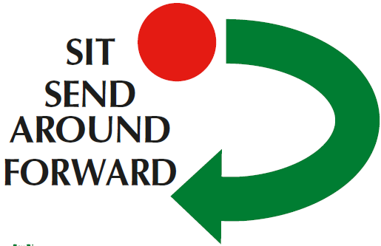
33. 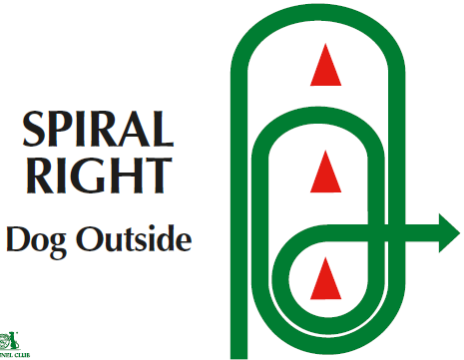
34. 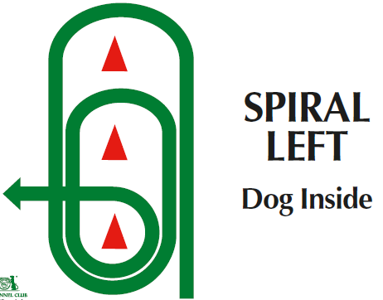
35. 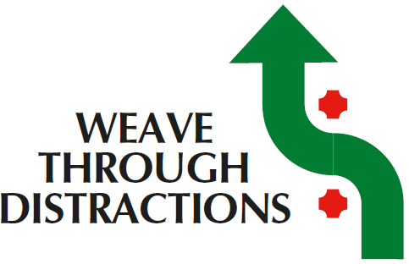
Bonus Ex 4 A
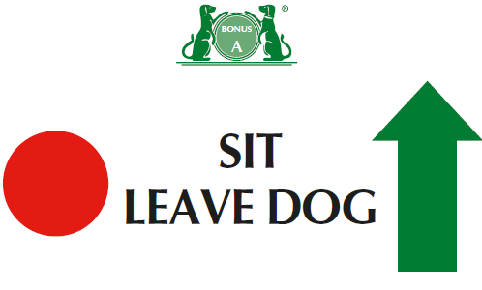
Bonus Ex 4 B
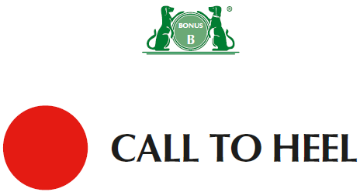
Bonus Ex 5 A
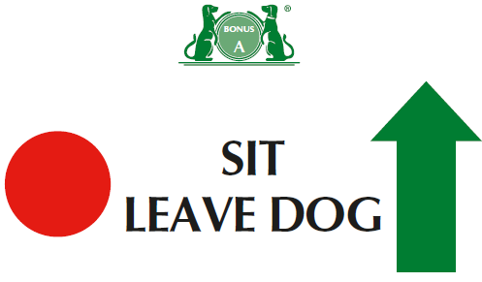
Bonus Ex 5 B
