Level 3 Mini Signs 2019
36 A. 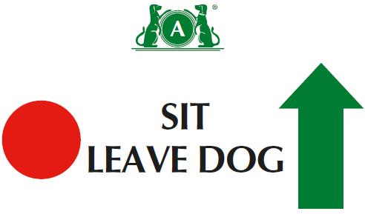
36 B. 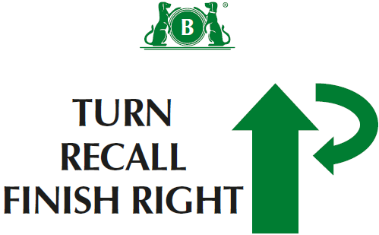
37 A. 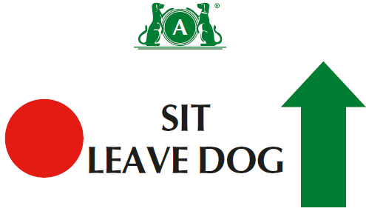
37 B. 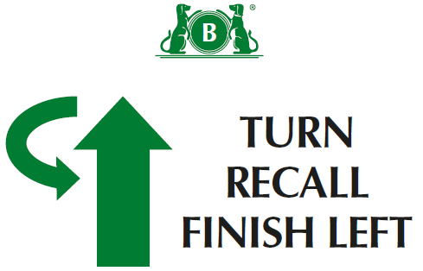
38. 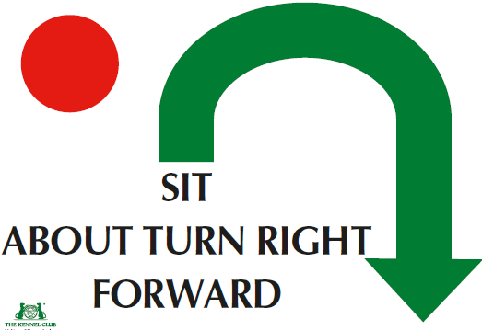
39. 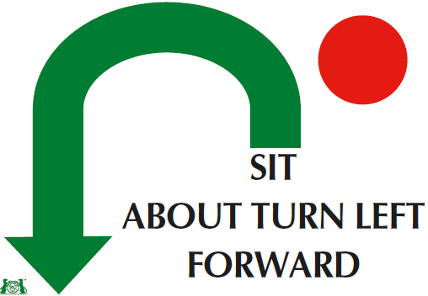
40. 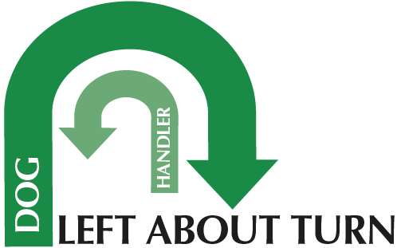
41. 
42. 
43. 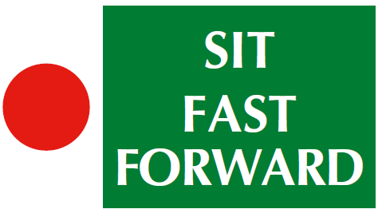
Level 3
(1) There should be a minimum of twelve and a maximum of fifteen exercises, with no more than eight static positions.
(2) There should be a ratio of one-third Level 3 exercises to two-thirds Level 1 and 2 exercises.
(3) A maximum of two exercises may be linked at this level.
(4) There should be a maximum of one Distraction Exercise, including the Bonus Exercise. (5)Can join 2 cone exercises using junction( ie across centre or at end at right angles)- advise use 1 different coloured cone if joining spiral to serpentine or fig 8.
(5) Bonus can come from Bonus exercises 1-8

(5) Bonus can come from bonus exercises 1 to 8
44 A. 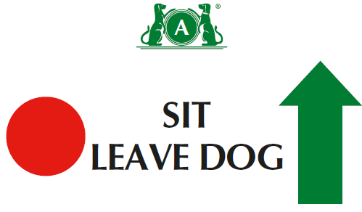
44 B. 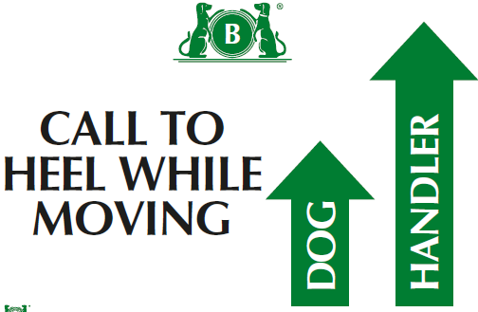
45. 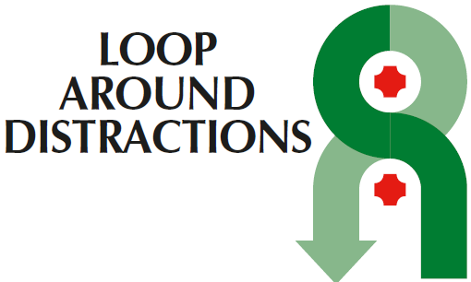
Bonus Ex 6
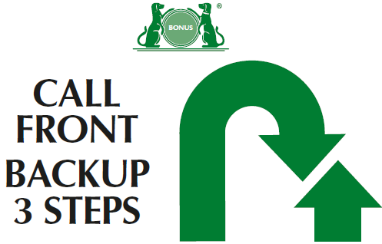
Bonus Ex 7 A
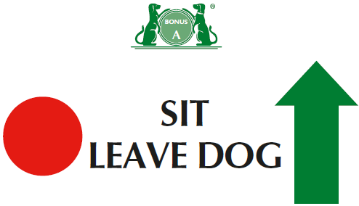
Bonus Ex 7 B
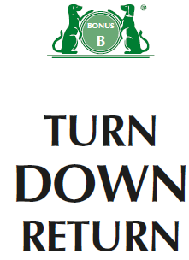
Bonus Ex 8 A
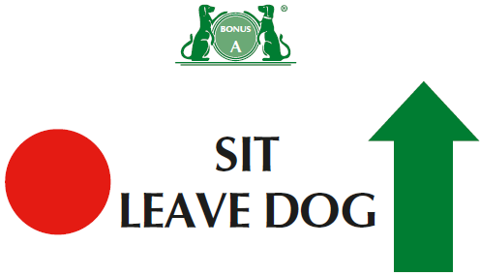
Bonus Ex 8 B
