Level 5 Mini Signs 2019
57 A. 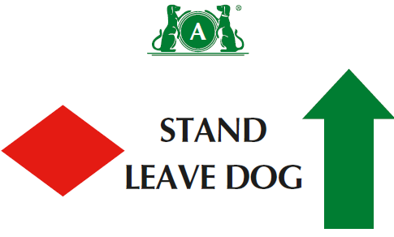
57 B. 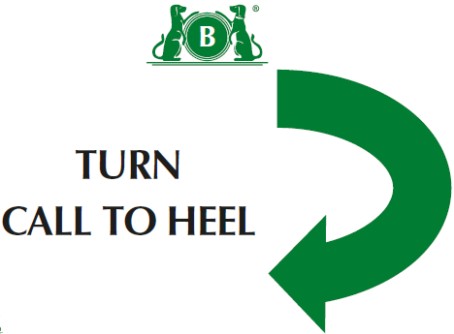
58. 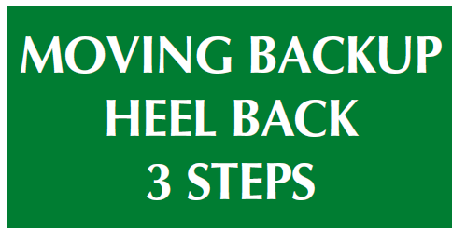
59. 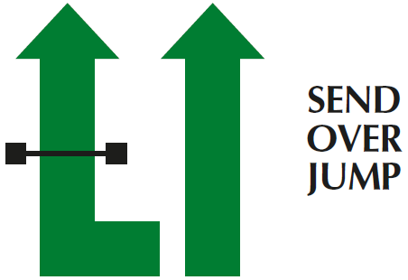
Level 5
(1) There should be a minimum of fifteen and a maximum of seventeen exercises, with no more than twelve static positions.
(2) There should be a minimum of one and a maximum of four exercises from Level 4, and a minimum of one and a maximum of four exercises from Level 5. )
(3) No more than 2 jump exercises in a course
(4) Can join 2 cone exercises using junction( ie across centre or at end at right angles)- advise use 1 different coloured cone if joining spiral to serpentine or fig 8

(5) Bonus can come from bonus exercises 1-12

60. 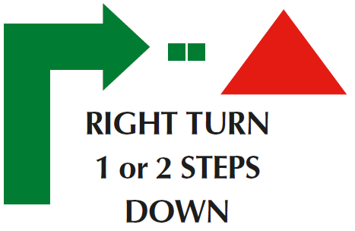
61. 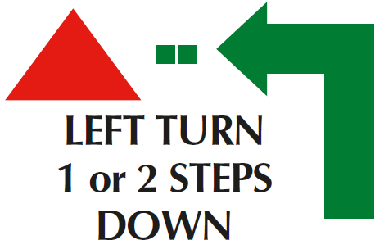
62. 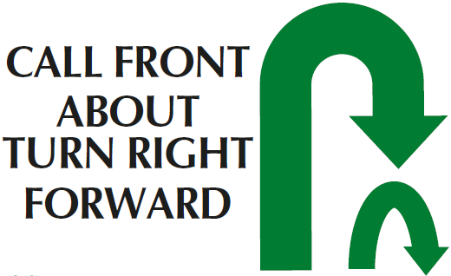
Bonus Ex 11
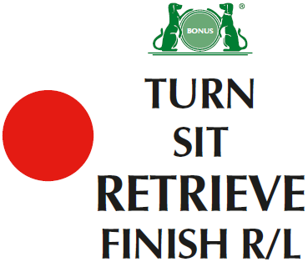

Bonus Ex 12 A
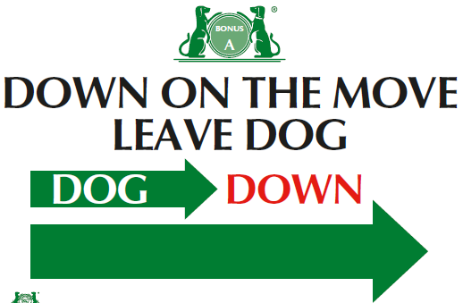
Bonus Ex 12 B
