Level 6 Mini signs 2019
63 A. 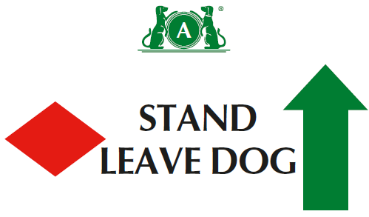
63 B. 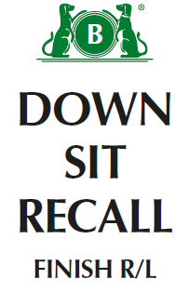
64 A. 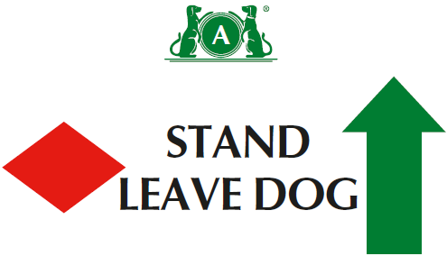
64 B. 
65 A. 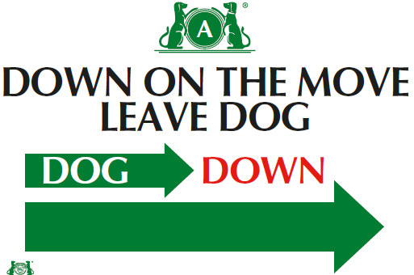
65 B. 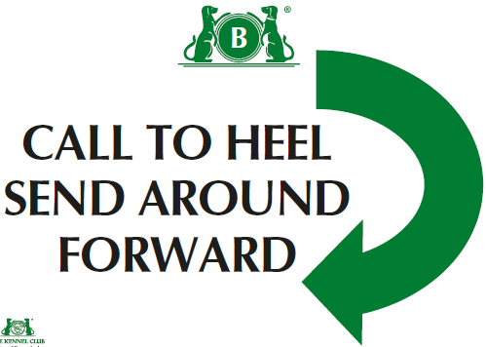
66 A. 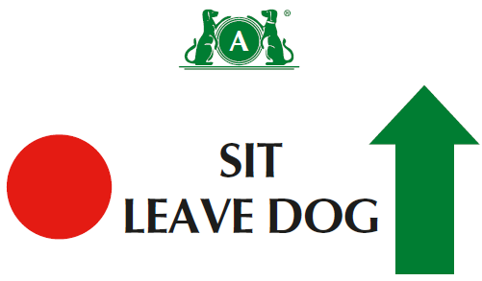
Level 6
(1) There should be a minimum of sixteen and a maximum of eighteen exercises, with no more than sixteen static positions.
(2) There should be a minimum of one and maximum of four exercises from Level 5, and a minimum of one and a maximum of four exercises from Level 6.
(3)No more than 2 jump exercises in a course.
(4)Can join 2 cone exercises using junction( ie across centre or at end at right angles)- advise use 1 different coloured cone if joining spiral to serpentine or fig 8
(5) Bonus can come from bonus exercises 1-15
66 B. 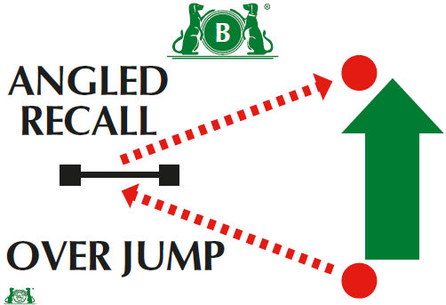
67. 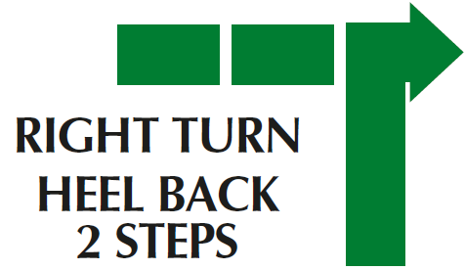
68. 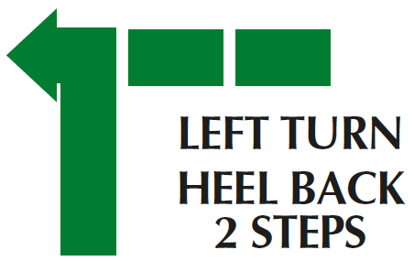

Bonus Ex 13.
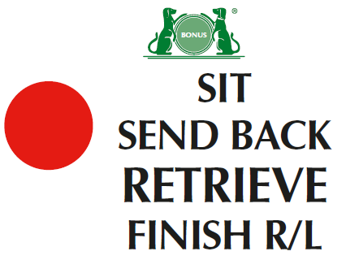
Bonus Ex 14
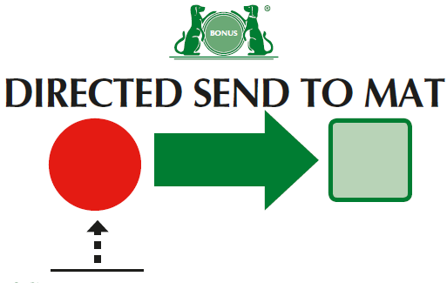
Bonus Ex 15
